

Refugee Sector Letter Kit

May 2026

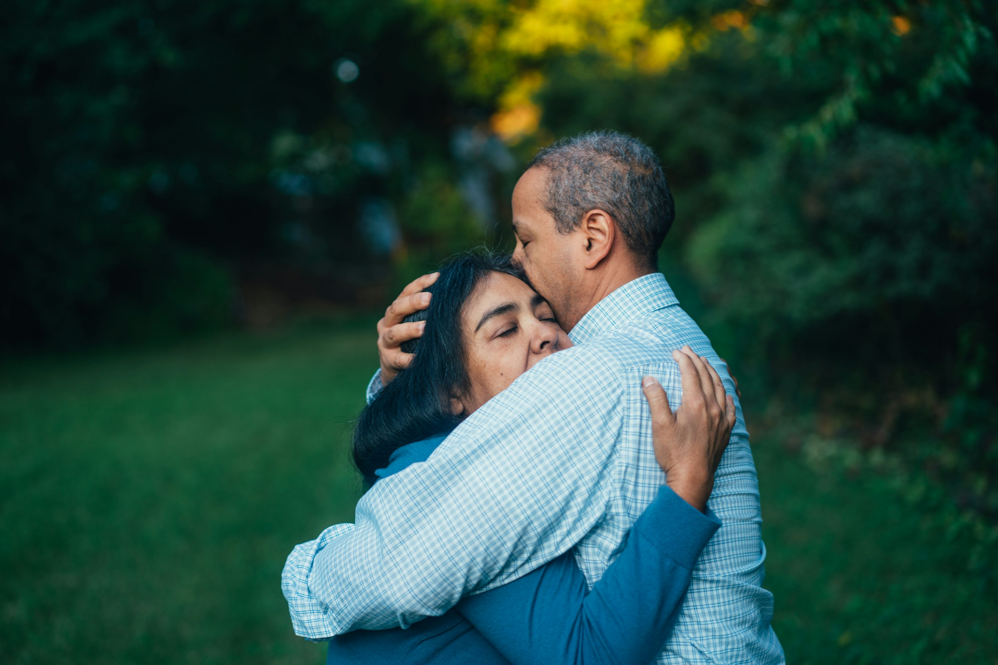
Family Reunion needs to be made easier for refugees

Photo by Gus Moretta on Unsplash

The Letter Kit is available to download at: https://aran.net.au/resources/letter-writing/
For information about the ARAN Letter Writing Network contact: austrefugeenetwork@gmail.com

WHY IT’S IMPORTANT TO WRITE NOW

Many refugees who waited for more than a decade on temporary visas, now have the security of a permanent visa. However, for many people who have partners, children or parents still in danger in home countries, or in precarious situations in countries where they are sheltering, there are still many uncertainties, and potentially profound disappointment and grief. For people who have already been living in uncertainty and separated from loved ones for more than a decade, the prospect of ongoing separation can be too much to bear.
Send a message to the Minister for Home Affairs Tony Burke, and his Assistant Ministers.
Send a copy to your local MP, Labor and Greens Senators in your state, Progressive Independents, and Leader of the Greens Larissa Waters and Senator David Shoebridge. Contact details are listed below.

Included in this kit is the information you need to create your own letters or use the sample letter:
- Background notes prepared by ARAN’s Letter Writing Network.
- Sample letter or email to politicians
- Contact details for MPs and Senators

Personalised letters and emails are best –
You might like to use the AIDA principle in drafting your letter
  - A - Attention - grab the recipient's attention. Say something positive about the reader that is directed towards the focus of your letter. Stimulate the recipient's curiosity
  - I - Interest & Information- encourage the recipient to read on.
  - D - Desire - Getting the reader to want to do what you are seeking - in their interest to do so.
  - A - Action- inform the reader of the action you want them to take.

~~~~~~~~~~~~~~~~~~~~~~~~~~~~~~~~~~~~~

BACKGROUND
Being granted a permanent visa is a huge relief, especially for people who have been waiting for so long. At last, they can feel they belong here in Australia and can think about building their future. Some have not seen their spouse or children since before their arrival to Australia. However, it soon it becomes evident that there are many barriers to them being able to reunite with loved ones. People in this situation can be at risk of serious depression and despair.
Refugees who travelled to Australia by boat cannot seek family reunion through the Humanitarian Program and must use the Family Migration Program instead.
This is a continuing form of punishment, because the Family Migration Program differs from the Humanitarian Family reunion program in several ways:
- Has a much narrower definition of who can be considered “family”, ie: partners, and dependent children.
- Has high visa application fees, whereas there are no fees under the Humanitarian Program. Under Family Migration Program, partner visa application fees are just under $10,000, the fee for a dependent over 18 is over $4,000, and for a dependent under 18 expensive is over $2,000. This means the cost of reuniting with a spouse and children can cost up to or more than $20,000, depending on the number of children.
- Age restrictions for ‘children’: Only children under 23 are eligible to be reunited with their parents. This means that a child who was only 12 when their parent fled to safety, may now be aged 24, and legally an adult, but still may be dependent and at risk. Some families have been placed the heart-wrenching situation of not being able to have their adult child join them here in Australia. They must remain an unsafe situation because they have turned 23.
- No access to settlement services after they arrive.

In addition to the restricted possibility of reunion with those considered family, there are then usual issues for refugees who are seeking to reunite with family members:

- Difficulties obtaining documentation and navigating complex administrative requirements. War, persecution, economic disadvantage and political instability can make it more difficult or dangerous to travel within the home country to obtain documents, such as passports or identity papers, or health and biometric data.

- Particular difficulties for LGBTIQ+ partners
There are significant challenges in providing evidence of a de facto relationship for refugees with LGBTQI+ backgrounds. In many countries, people with LGBTQI+ backgrounds are persecuted – and this can result in people having to flee and seek refugee status. Partners left behind are in a particularly precarious situation, being subjected to cultural shame, stigma, and discrimination. Because it has been necessary for relationships to be kept secret, it is also often difficult to produce evidence of the relationship. For people with LGBTQI+ backgrounds who also have children there are likely to be added difficulties.

- Family reunion is often a long process, and the uncertainty about if, and when people will be reunited with their loved ones can result in mental health issues, especially for those who have experienced long periods of acute uncertainty about being granted refugee status and being given permanent visa.

All of these uncertainties further inhibit family reunion and add significant emotional and financial strain.

The following reforms are recommended:
- Introduce visa application charge concessions for refugees.
- Adapt visa processing to address the challenges obtaining identity documents and health and biometric data.
- Change the legal definitions of “dependent” and “member of the family unit” to better reflect the diverse family structures in many refugee communities.
- Develop specific guidance around the processing of partners from LGBTIQ+ backgrounds in consultation with relevant community groups.

Further background:
See more detail in the policy brief prepared by RCOA in March 2025, which was also supported by many other organisations: https://www.refugeecouncil.org.au/wp-content/uploads/2025/04/Family-reunion-brief-2025.docx.pdf

Fact sheet from RAILS (refugee legal service in Qld) . Please note there may have bene some minor changes since this was published in 2020.

General Information on the importance of Family Reunion for refugees (RCOA 2021) Note: this paper does not address the specific difficulties for those on RoS Visa holders.

SAMPLE LETTER
Remember to make this letter your own, with a few tweaks etc . Make sure you remove the last paragraph when sending to Minister Burke.

- If you are posting a letter, either print off, sign and send, or hand write your letter.
- If you are emailing, just copy the letter into an email

Dear MP/Senator we’ll also suggest people send to progressive Independents and Greens – Larissa Waters and David Shoebridge – see details below
I am writing with concerns about the ongoing unfairness for people seeking asylum who arrived by boat between 2009-2014 and went through the flawed ‘Fast Track’ protection process.
After more than a decade of uncertainty, many have finally been granted a permanent Resolution of Status (subclass 851) visa. This is a very welcome outcome for people who have been forced to live for years in Australia with great uncertainty, and without their loved ones.
However, for many, this long-awaited outcome is undermined by continuing challenges.
These include having to navigate costly, complex and lengthy family reunion processes.
Implementing the following reforms to resolve these challenges would greatly assist people who endured ‘Fast Track’ to finally settle fully in Australia after living in uncertainty for many years
- Introducing visa application charge concessions, to make it more affordable for people to reunite with their partners and/or children.
- Adapting visa processing to address the challenges obtaining identity documents and health and biometric data for family members.
- Changing the legal definitions of “dependent” and “member of the family unit” to reflect the diverse family structures in many refugee communities.
- Developing specific guidance around the processing of partners from LGBTIQ+ backgrounds in consultation with relevant community groups.
Without family reunion, the safety of people who endured the flawed ‘Fast Track’ process remains incomplete and the capacity of people to fully settle here in Australia is compromised.
The importance of these changes, and the urgency of this matter is illustrated in the case study below.
I ask that you make a representation to Minister for Home Affairs Tony Burke on my behalf requesting that changes outlined in this letter be made to facilitate family reunion for those who have been living in limbo for more than a decade.
Thank you for considering these important issues.
Yours sincerely,

[Name]
[address, email and phone number]

Family Reunion Processes - Case Study:

Amir (not his real name) and his family fled Afghanistan after being persecuted by the Taliban and sheltered in Pakistan for many years. When violence against people of his ethnicity and religion escalated in their area of Pakistan, he decided to take the journey to Australia to try to secure safety for his family. For almost 12 years, Amir remained on a series of Bridging and Safe Haven Enterprise Visas. With these being only temporary visas, he was precluded from applying to bring his family to live with him in safety.

When Amir’s permanent visa was finally granted, he immediately applied for visas for his wife and children. However, he discovered that his oldest child would not be eligible for family reunion due to the fact that she was now 24 years old. This news was devastating for Amir. He was forced to choose between leaving his whole family together, indefinitely separated from him in an unsafe and insecure situation, or leave just one beloved daughter behind on her own.

Eventually, Amir made the decision to leave his daughter in Pakistan with extended family and work towards sponsoring her separately in the future. He worries about her constantly, especially as asylum seekers are periodically returned to Afghanistan by the Pakistani government. She was just 12 years old when he left for Australia to find a safe place for his family. What should have been a joyous family reunion has been marred with the ongoing grief of having to leave one child behind.

POLITICIANS to write to: CONTACT DETAILS:
If posting letters:
Prime Minister: PO Box 6022, Parliament House, CANBERRA ACT 2600
Minister Tony Burke: PO Box 6022, Parliament House, CANBERRA ACT 2600
Members of the House of Representatives: PO Box 6022, Parliament House, CANBERRA ACT 2600
Senators: PO Box 6100, Parliament House, CANBERRA ACT 2600
Your local MP – find their electoral office address at Search for individual MPs & Senators here

Sending your letter by email:
- Minister Home Affairs, The Hon Tony Burke: Tony.Burke.mp@aph.gov.au
- Assistant Minister Immigration, The Hon Matt Thistlethwaite Matt.Thistlethwaite.MP@aph.gov.au
- Assistant Minister for Citizenship, Customs and Multicultural Affairs: The Hon Julian Hill: Julian.Hill.MP@aph.gov.au
- To find details for individual MPs and Senators use this link to Search for individual MPs & Senators on the Parliament House website
- You might find this listing helpful: Listing of all MPs and Senators Sept 2025. Please download the spreadsheet if you want to sort etc for your own use. This spreadsheet was updated in Sept 2025. If you find any errors, please email info@refugeeadvocacynetwork.org,.au and we’ll make corrections.

Senators by State
ACT: ALP: senator.katy.gallagher@aph.gov.au;
IND: senator.david.pocock@aph.gov.au;
NSW: ALP : senator.ayres@aph.gov.au; senator.mcallister@aph.gov.au; senator.oneill@aph.gov.au; senator.sheldon@aph.gov.au;
GREENS: senator.faruqi@aph.gov.au; senator.shoebridge@aph.gov.au;
LIBERAL: senator.bragg@aph.gov.au; senator.kovacic@aph.gov.au; senator.sharma@aph.gov.au;
NATS: senator.cadell@aph.gov.au
NT: ALP: Senator.McCarthy@aph.gov.au;
LIBERAL: senator.nampijinpaprice@aph.gov.au;
QLD: ALP: senator.chisholm@aph.gov.au; senator.mulholland@aph.gov.au; senator.green@aph.gov.au; senator.watt@aph.gov.au;
GREENS: senator.allman-payne@aph.gov.au; senator.waters@aph.gov.au;
LIBERAL: senator.scarr@aph.gov.au;
LNP: senator.mcdonald@aph.gov.au; senator.mcgrath@aph.gov.au;
PHON: senator.hanson@aph.gov.au; senator.roberts@aph.gov.au;
SA: ALP: senator.walker@aph.gov.au; senator.farrell@aph.gov.au; senator.grogan@aph.gov.au; senator.marielle.smith@aph.gov.au; senator.wong@aph.gov.au;
GREENS: senator.hanson-young@aph.gov.au; senator.pocock@aph.gov.au;
LIBERAL: senator.antic@aph.gov.au; senator.blyth@aph.gov.au; senator.liddle@aph.gov.au; senator.mclachlan@aph.gov.au; senator.ruston@aph.gov.au;
TAS: ALP: senator.bilyk@aph.gov.au; senator.; carol.brown@aph.gov.au; senator.polley@aph.gov.au; senator.urquhart@aph.gov.au; senator.dowling@aph.gov.au; senator.dolega@aph.gov.au;
GREENS: senator.mckim@aph.gov.au; senator.whish-wilson@aph.gov.au;
LIBERAL: senator.askew@aph.gov.au; senator.chandler@aph.gov.au; senator.colbeck@aph.gov.au; senator.duniam@aph.gov.au;
JLN: senator.lambie@aph.gov.au;
IND: senator.tyrrell@aph.gov.au;
VIC: ALP: senator.ciccone@aph.gov.au; senator.darmanin@aph.gov.au; senator.stewart@aph.gov.au; senator.walsh@aph.gov.au; senator.ananda-rajah@aph.gov.au;
GREENS: senator.hodgins-may@aph.gov.au;
LIBERAL: senator.henderson@aph.gov.au; senator.hume@aph.gov.au; senator.hume@aph.gov.au; senator.paterson@aph.gov.au;
NATS: senator.mckenzie@aph.gov.au;
UAP: senator.babet@aph.gov.au;
WA: ALP: senator.cox@aph.gov.au; senator.ghosh@aph.gov.au; senator.lines@aph.gov.au; senator.sterle@aph.gov.au; senator.whiteaker@aph.gov.au;
IND: senator.payman@aph.gov.au;
GREENS: senator.steele-john@aph.gov.au;
LIBERAL: senator.brockman@aph.gov.au; senator.cash@aph.gov.au; senator.matt.o'sullivan@aph.gov.au; senator.smith@aph.gov.au;

PROGRESSIVE INDEPENDENTS

Dr Sophie Scamps Sophie.Scamps.Mp@aph.gov.au PO Box 523 Narrabeen NSW 2101
Zali Steggall Zali.steggall.mp@aph.gov.au; P O Box 450, Manly, NSW 2095
Allegra Spender allegra.spender.mp@aph.gov.au Suite 302 Level 3 179-191 New South Head Road, Edgecliff (PO Box 545) NSW
Nicolette Boele nicolette.boele.mp@aph.gov.au; Suite 1, Level 2, 280 Pacific Highway, Lindfield, NSW 2070
David Pocock Senator.David.Pocock@aph.gov.au PO Box 705 Gungahlin ACT 2912
Dr Monique Ryan Monique.Ryan.MP@aph.gov.au 105 Camberwell Rd Hawthorn East VIC 3123 (PO Box 1227)
Lidia Thorpe senator.thorpe@aph.gov.au 474 Smith St, Collingwood VIC 3066 (PO Box 1526)
Andrew Wilkie Andrew.Wilkie.MP@aph.gov.au 188 Collins St Hobart Tas 7001 (PO Box 32)
Fatima Payman senator.payman@aph.gov.au GPO Box B58, Perth WA 6838
Kate Chaney kate.chaney.mp@aph.gov.au 98/ 5 Howtree Place, Floreat WA 6014 (PO Box 186 Floreat 6014)

GREENS POLITICIANS
Leader of the Greens - Senator Larissa Waters (Qld): senator.waters@aph.gov.au
Senator David Shoebridge (NSW) : senator.shoebridge@aph.gov.au

