At least 10 refugees in PNG
Need URGENT MEDICAL CARE
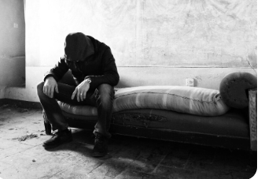
MEDICAL
EVACUATION
NOW

