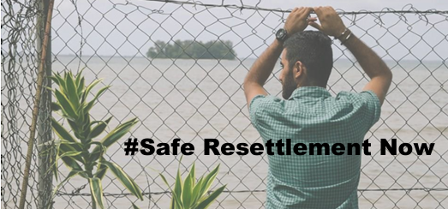
Australia must provide safe resettlement to all those who are currently or have been held offshore in PNG or Nauru

