
Refugee Sector Letter Kit

July 2025

Available to download at:
- https://aran.net.au/resources/letter-writing/
- https://ruralaustraliansforrefugees.org.au/write-a-letter

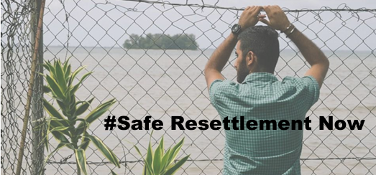
More than 12 Years of Uncertainty and Trauma must end:
- Australia must immediately medevac those who are critically ill on PNG
- Australia must provide safe resettlement to all those who are currently or have been held offshore.
- Australia must abandon the policy of offshore processing.
Add your voice to the call to end Australia’s offshore regime:
- Join organisations and individuals across Australia to call on the re-elected Albanese Government to end Australia’s cruel offshore processing and detention regime, and for the urgent evacuation of those still held in PNG and Nauru, in particular, those requiring urgent medical care.
- Also consider writing to the Editor of your local paper.
Send a message to your local MP, the Prime Minister and the Minister for Home Affairs before the first sitting of the new Parliament resumes on 22 July – ideally in the week beginning 14 July.
Included in this kit is the information you need to create your own letters or use the proformas
- Background notes prepared by ARAN’s Letter Writing Network.
- Suggested points to mention in your letter or email to politicians
- Suggestion to also write a short letter to the Editor
- Contact details for MPs and Senators

Personalised letters and emails are best –
You might like to use the AIDA principle in drafting your letter
  - A - Attention - grab the recipient's attention. Say something positive about the reader that is directed towards the focus of your letter. Stimulate the recipient's curiosity
  - I - Interest & Information- encourage the recipient to read on.
  - D - Desire - Getting the reader to want to do what you are seeking - in their interest to do so.
  - A - Action- inform the reader of the action you want them to take.

~~~~~~~~~~~~~~~~~~~~~~~~~~~~~~~~~~~~~
The ARAN Letter Writing Network
Contact: austrefugeenetwork@gmail.com

BACKGROUND INFORMATION
Australia’s offshore processing and detention regime has been routinely criticised for being cruel and blatantly violating human rights. Since PM Howard first established offshore processing on Nauru and Manus Island in 2001, thousands of people have suffered deprivation of freedom, cruelty and abuse, and denial of their right to seek asylum in Australia. These people bear the emotional scars and many continue to live with poor physical and mental health.
The offshore processing regime is also exorbitantly expensive, costing approximately $1billion annually.
See just one of the numerous United Nations reports of the many condemning offshore processing: Australia responsible for arbitrary detention of asylum seekers in offshore facilities, UN Human Rights Committee finds | OHCHR (9 January 2025) In this report the UN affirmed that Australia cannot simply walk away from its responsibilities towards people it sends offshore, calling on the Australian government to promptly compensate people for violating their human rights under the offshore regime.
The media release by the Asylum Seeker Resource Centre(ASRC) in January 2025: UN Human Rights Committee condemns Australia offshore detention policy
Research shows people held offshore are 20 times more likely to suffer PTSD: Offshore detention makes it 20 times more likely asylum seekers will suffer PTSD, Australian study finds | Australian immigration and asylum | The Guardian
Read the ASRC’s report: 'Cruelty by design: the health crisis in offshore detention'
- Australia must provide safe resettlement to all those who have been held offshore.
- Australia must abandon the policy of offshore processing.
CURRENT SITUATION in PNG:
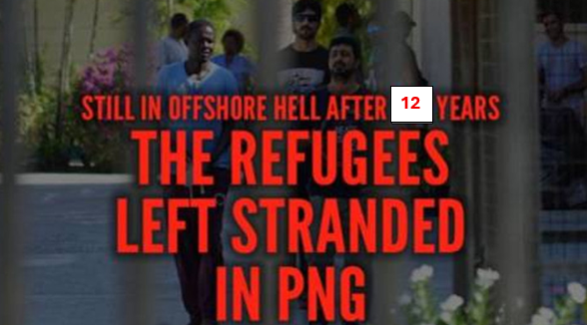
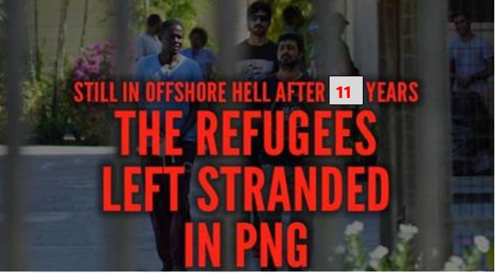
Having been held in detention in harsh and inhumane conditions on Manus Island for many years, 37 men, some now with partners and children, are still trapped in PNG. After so many years of uncertainty and despair, some of these men are very ill, and need specialist mental health care - they need to be brought to Australia for urgent medical care. After 12 years, this cruel limbo must end.
Media report from PNG June 2025: “….. on a dusty hill on the edge of Port Moresby is the ragged, desperate end to Australia’s illegal offshore detention regime in Papua New Guinea….. Samad Abdul was 23 when he arrived in Australia by boat seeking asylum…..he is now 35……The persecution he faced in his home in Quetta, Pakistan, has been formally recognised. He has a ‘well-founded fear of being persecuted’ in his homeland. He cannot be returned there, and Australia has a legal obligation to protect him……Hundreds of refugees once detained on Manus alongside Abdul have since left PNG. They now live in Europe, the US, Canada, New Zealand and Australia.”
The UNHCR has been urging Australia to evacuate those who are seriously ill to Australia for medical care.
- Australia must immediately medevac those who are critically ill on PNG
- Australia must arrange genuinely safe resettlement pathways for all those still trapped in PNG, including settlement in Australia.

CURRENT SITUATION in NAURU:
Ten years after restarting offshore processing on Nauru, in mid-2023 the Albanese Government ceased offshore processing there, with the asylum seekers remaining there either resettled elsewhere, or brought to Australia. However, it was only a few months before people were once more detained there and now there are around 100 refugees and people seeking asylum there.
Update from ASRC – June 2025: There remains a lack of transparency from the Australian government about the treatment, conditions and plan for the refugees and people seeking asylum on Nauru. These people are arbitrarily and indefinitely detained and have been there from 1-21 months. History on Nauru is repeating with people reporting the following:
- physical and mental health deterioration the longer they remain there
- concerns about the limited healthcare available to them
- people are destitute, lacking in nutrition and suffering weight loss as they struggle to meet living costs on Nauru on the meagre $230 per fortnight allowance.
Some people are already being recognised as refugees, however with no resettlement options available to them they are stuck.

ASRC is in direct contact with people on Nauru, providing a critical lifeline and casework support, and is also lobbying, campaigning and advocating for the following:
- Medical evacuation of people held offshore on Nauru & Papua New Guinea (PNG), including family members, to safety in Australia for urgent medical treatment, and provision of necessary supports and a clear and swift pathway to permanency for those who do not have resettlement options.
- An end to the policy of sending people who come by sea to seek asylum to offshore detention, and support for people to live in the Australian community while their applications for protection are being processed. People found to be refugees should be permanently and swiftly resettled.
- A Royal Commission into Australia’s immigration detention regime.

IDEAS for LETTERS TO THE EDITOR
Consider using material from the background provided here – and also points from the sample letter below.
Tips for writing letters to the Editor:
- Be clear and concise about the issue you are raising (you will need to choose just one or two key points, as you don’t have the space to fully explain a complex situation)
- It’s helpful if you can link to something topical in the news
- PM Albanese’s appeal to ‘kindness’ post the election win is still relevant
- Assume that the readers don’t know much – if anything about the issue
- Make it clear what you are concerned/outraged about
- Make it clear what you think should happen
You’ll find more useful tips here: https://www.climatecouncil.org.au/how-write-effective-letter-editor/ (produced by the Climate Council) and here: https://www.naeyc.org/our-work/public-policy-advocacy/letter-editor-template
Some useful tips here also: https://www.raisetherate.org.au/letter_to_the_editor
SAMPLE LETTER to POLITICIANS Remember to tweak this letter to make it your own – and make necessary changes if sending to non-Labor politicians
Dear
The ban on resettlement in Australia imposed on people arriving by boat after 19 July 2013 continues to cause terrible harm to people who simply sought a safe home in Australia to rebuild their lives. I feel deep shame that, as a consequence of this ban, Australian governments over many years have been responsible for the immense suffering of those who were forcibly sent offshore to Nauru and PNG and who were denied the right to seek protection in Australia.
International and Australian human rights bodies have criticised Australia’s offshore program and, as recently as January 2025, the United Nations confirmed that under international law Australia continues to be responsible for the people it sends offshore. Research shows that people held offshore are 20 times more likely to experience post-traumatic stress disorder. More than 14 untimely deaths can be directly attributed to offshore processing; but the Australian Government continues to spend billions of dollars on this cruel policy.
Over 100 people who arrived in Australia seeking asylum are now on Nauru – for how long? And how will they find safe resettlement? This government has no resettlement plan and no strategy for ending this cycle of harm. The Asylum Seeker Resource Centre reports that people who have now been there for an extended period are experiencing mental health issues.
In PNG, of the 37 men who have now been there for 12 years, there are some who have developed very severe mental health conditions. It is abhorrent that Australia has abandoned these men in PNG, having held them in appalling detention conditions for many years, and now exposing them to impoverishment and critical illness. Australia is responsible for the welfare of these men who sought our protection more than 11 years ago, and it is incumbent on the Albanese Government to find safe and durable resettlement options for them, including resettlement in Australia.
In Australia, there are around 1,000 people who were evacuated from PNG or Nauru and have been living in our community for years who are still denied any pathway to permanency in this country. Some do not have work rights, some do not have rights to education. All live on precarious short-term bridging visas that generally have to be renewed every 3-6 months. Many are separated from their loved ones. They have now lived in our community for many years, and their children who have grown up here only know Australia as their home. They need to have the security of permanent visas.

I urge you to:
- take immediate action to bring the critically ill refugees still in Port Moresby to Australia for urgently needed mental health and medical care
- provide safe resettlement to all those who are currently or have been held offshore.
- create pathways to permanency in Australia for those people living in our community who were previously evacuated from Australia’s offshore facilities.
- use your influence to ensure that Australia abandons the policy of offshore processing.
I hope that you and your Labor colleagues will take immediate action on behalf of those who are desperately ill and find safe settlement options for all those held in PNG and on Nauru, and those still in visa limbo in Australia.
Yours sincerely

(name)
(Address)

Who to write to: CONTACT DETAILS:
If posting letters:
Prime Minister: PO Box 6022, Parliament House, CANBERRA ACT 2600
Minister Tony Burke: PO Box 6022, Parliament House, CANBERRA ACT 2600
Senators: Post to: PO Box 6100, Parliament House, CANBERRA ACT 2600
Your local MP – find their electoral office address at Search for individual MPs & Senators here

Sending your letter by email:
- Prime Minister - use the contact form: https://www.pm.gov.au/contact-your-pm
- Minister Tony Burke: tony.burke.mp@aph.gov.au
- Your local MP – if they are Labor, Greens or progressive Independent. Use this link to Search for individual MPs & Senators on the Parliament House website
- Labor and Greens Senators in your state

Senators by State
ACT: ALP: senator.katy.gallagher@aph.gov.au;
IND: senator.david.pocock@aph.gov.au;
NSW: ALP : senator.ayres@aph.gov.au; senator.mcallister@aph.gov.au; senator.oneill@aph.gov.au; senator.sheldon@aph.gov.au;
GREENS: senator.faruqi@aph.gov.au; senator.shoebridge@aph.gov.au;
NT: ALP: Senator.McCarthy@aph.gov.au;
QLD: ALP: senator.chisholm@aph.gov.au; senator.mulholland@aph.gov.au; senator.green@aph.gov.au; senator.watt@aph.gov.au;
GREENS: senator.allman-payne@aph.gov.au; senator.waters@aph.gov.au;
SA: ALP: senator.walker@aph.gov.au; senator.farrell@aph.gov.au; senator.grogan@aph.gov.au; senator.marielle.smith@aph.gov.au; senator.wong@aph.gov.au;
GREENS: senator.hanson-young@aph.gov.au; senator.pocock@aph.gov.au;
TAS: ALP: senator.bilyk@aph.gov.au; senator.carol.brown@aph.gov.au; senator.polley@aph.gov.au; senator.urquhart@aph.gov.au; senator.dowling@aph.gov.au; senator.dolega@aph.gov.au;
GREENS: senator.mckim@aph.gov.au; senator.whish-wilson@aph.gov.au;
VIC: ALP: senator.ciccone@aph.gov.au; senator.darmanin@aph.gov.au; senator.stewart@aph.gov.au; senator.walsh@aph.gov.au; senator.ananda-rajah@aph.gov.au;
GREENS: senator.hodgins-may@aph.gov.au;
WA: ALP: senator.cox@aph.gov.au; senator.ghosh@aph.gov.au; senator.lines@aph.gov.au; senator.sterle@aph.gov.au; senator.whiteaker@aph.gov.au;
IND: senator.payman@aph.gov.au;
GREENS: senator.steele-john@aph.gov.au;
Need more contacts ?
Listing of all MPs and Senators June 2025 This spreadsheet has been updated in June 2025 – but if you find any errors please email info@refugeeadvocacynetwork.org,.au and we’ll make corrections. Please download the spreadsheet if you want to sort etc for your own use.

Australia responsible for arbitrary detention of asylum seekers in offshore facilities, UN Human Rights Committee finds | OHCHR
Offshore detention makes it 20 times more likely asylum seekers will suffer PTSD, Australian study finds | Australian immigration and asylum | The Guardian

