United Nations Human Rights Report condemns Australia’s arbitrary detention of asylum seekers in offshore facilities

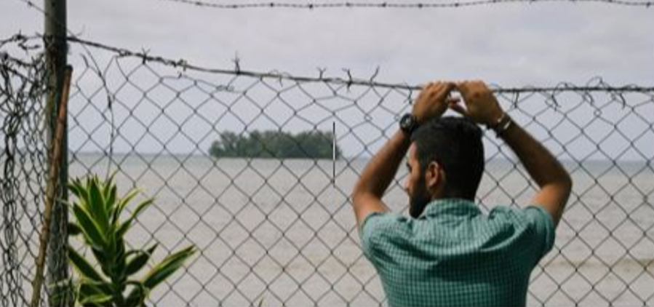

This letter writing kit is available to download at:
- https://aran.net.au/resources/letter-writing/
- https://ruralaustraliansforrefugees.org.au/write-a-letter

Included in this kit is the information you need to create your own letters or use the proformas
- Guide and Background notes prepared by ARAN’s Letter Writing Network.
- Postal and email addresses for MPs and Senators, Minister and PM
- Sample letter and/or Suggested points to mention in your letter or email.

Personalised letters are best – You might like to use the AIDA principle
  - A - Attention - grab the recipient's attention. Say something positive about the reader that is directed towards the focus of your letter. Stimulate the recipient's curiosity
  - I - Interest & Information- encourage the recipient to read on.
  - D - Desire - Getting the reader to want to do what you are seeking - in their interest to do so.
  - A - Action- inform the reader of the action you want them to take.
~~~~~~~~~~~~~~~~~~~~~~~~~~~~~~~~~~~~~
To contact the ARAN Letter Writing Network email austrefugeenetwork@gmail.com

Why it’s important to write about this issue
In January this year, the UN Human Rights Committee found Australia to be in breach of International Human Rights law in its offshore detention policy for asylum seekers. The Committee has called for an end to offshore processing, a revision of our migration laws to protect the human rights of those seeking asylum as well as compensation for those complainants who brought their case to the UN. See report here: Australia responsible for arbitrary detention of asylum seekers in offshore facilities, UN Human Rights Committee finds | OHCHR. The Australian Government has yet to respond.
We are calling for the termination of offshore detention, compensation for the victims of this incarceration, and for all asylum seekers and refugees forcibly detained on Nauru Island to be brought ashore for processing and protection.
Write to your federal parliamentarian, senators, the Prime Minister and the Minister for Home Affairs.

BACKGROUND INFORMATION
- Australia signed a Memorandum of Understanding with Nauru in 2012 and again in 2013, allowing Australia to forcibly redirect/transfer asylum seekers to the Republic of Nauru.
- According to the Refugee Council of Australia - 4,183 asylum seekers (many of whom were later deemed refugees) were sent to Nauru between 2012 and 2023 by the Australian Government. The Centre was finally emptied in 2023 – but remained open, and it did not stay empty for long.
- Currently there are approximately 100 asylum seekers detained on Nauru, some in closed detention.
- There are numerous reports of the conditions experienced there from over the years. All are similar. From Amnesty International in 2016: A Human Rights catastrophe . . . a toxic mix of uncertainty, unlawful detention and inhumane conditions.” https://www.amnesty.org.au/island-of-despair-nauru-refugee-report-2016/
- As a result of their traumatic incarceration on Nauru, two parties filed their complaints with the Human Rights Committee claiming Australia had violated its obligations under the International Covenant on Civil and Political Rights particularly article 9 regarding arbitrary detention
- In the first case, 24 unaccompanied minors from Iraq, Iran, Afghanistan, Pakistan, Sri Lanka and Myanmar took their case to the UN. All of these minors suffered a catastrophic deterioration of wellbeing whilst in detention, including weight loss, self-harm, kidney problems and insomnia. They were diagnosed with the life threatening ‘resignation syndrome’. The second case was filed by an Iranian family protesting their right to challenge their detention in court.
- In January 2025, in response the United Nations Human Committee ruled that the Australian Government was responsible for the prolonged and arbitrary detention of asylum seekers re-directed or transferred to offshore detention facilities in the Republic of Nauru.
‘ A state party cannot escape its human rights responsibility when outsourcing asylum processing to another state . . . Where a state exercises effective control over an area, its obligations under international law remain firmly in place and cannot be transferred.’ El Haiba. El Haiba also states. ‘ Australia had control and influence over the regional processing facility in Nauru and thus we consider that asylum seekers in those cases were within the state party’s jurisdiction.’
(Australia responsible for arbitrary detention of asylum seekers in offshore facilities, UN Human Rights Committee finds | OHCHR,)
- The Australian Government has not yet officially responded but stated, ‘It has been the Australian Government’s consistent position that Australia does not exercise effective control over regional processing centres,’ said a spokesperson for the Department of Home Affairs (Australia violated rights of asylum seekers held in Nauru, UN watchdog says | Human Rights News | Al Jazeera)
- The United Nations Human Rights Committee has recommended that:
The Australian Government pay compensation to the victims
Take steps to ensure similar violations do not re-occur
Review migration legislation and bilateral transfer agreements to align with international human rights standards
For further Information:
https://www.amnesty.org.au/nauru-detention-centre-must-be-urgently-evacuated-in-light-of-un-ruling/
https://www.abc.net.au/news/2025-01-10/australia-violates-human-rights-treaty-with-nauru-detention-un/104802684

We suggest you write to:
- Your local MP whichever party they belong to. Find details for your MP here
- Listing of all federal senators sorted by state (you can copy email addresses from this listing and send BCC to all senators in your state (or a selection of them), addressing your email with Dear Senator,
- If you are writing letters to senators, Find details for your senators here
Also write to
The Prime Minister, Anthony Albanese Contact form: https://www.pm.gov.au/contact
The Hon Tony Burke, Minister for Home Affairs, Minister for Immigration and Multicultural Affairs, Minister for Cyber Security; Tony.Burke.MP@aph.gov.au
When sending emails remember to include your NAME and ADDRESS
Letters to PM and Ministers should be posted to PO Box 6022, Parliament House, Canberra 2600

SAMPLE LETTER (this letter is provided as a guide – please make a few tweaks to individual your letter)
(date)

Dear ( MP /Senator/ Minister /PM)
Australia has been a signatory of the United Nations Refugee Convention on Human Rights since 1952. As such, we are obliged to provide sanctuary for asylum seekers fleeing persecution and war. We have long failed refugees and asylum seekers who arrive on our shores by sea. This requires immediate attention and policy changes as outlined in the recent report of the UN Human Rights Committee.
Since 2012, Australia has been detaining refugees and asylum seekers on Nauru with impunity, claiming the host country is responsible for human rights abuses. The UN Human Rights Committee has this year found, after deliberating for 9 years on 2 separate claims, that this is a fallacy, and that Australia is responsible for arbitrary detention of asylum seekers in offshore facilities, and related harms.
Australia signed Memoranda of Understanding with Nauru in 2012 and 2013, allowing Australia to forcibly redirect and transfer asylum seekers to Nauru for processing. In response to the aforementioned complaints, Committee Member Mahjoub El Haiba said, ” A State party cannot escape its human rights responsibility when outsourcing asylum processing to another state...Where a State exercises effective control over an area, its obligations under international law remain firmly in place and cannot be transferred.”
The Committee stated it was established that Australia exercised significant control and influence over the regional processing facility in Nauru, and the asylum seekers listed in the complaints were within the State party’s jurisdiction under the International Covenant on Civil and Political Rights (ICCPR). The Committee observed that asylum seekers were forcibly redirected or transferred to Nauru; that once refugee status was established, refugees continued to be detained for a long time; that Australia had arranged for the construction and establishment of the Regional Processing Centre, financed it and contracted with other entities to run it.
Not only has the UN Committee found Australia’s offshore detention policy to be in breach of the Geneva Convention, but it has deemed complainants to be owed compensation for the neglect and abuse they experienced. The Committee called on Australia to take steps to ensure that similar violations do not recur, specifically urging a review of migration legislation and bilateral transfer agreements to align them with international human rights standards.
It is my understanding that the Government has not yet responded to the Committee’s findings and is ‘considering’ its response. I am also aware that Management Training Corporation (MTC), a US security contractor with a record of abuse was recently contracted to operate the Regional Processing Centre. Given previous experience on Nauru, this contract is likely to produce further claims of abuse.
I urge the Government, through the Minister for Immigration and Multicultural Affairs and Home Affairs, to honour its commitment to the Geneva Convention. I call on the Government to:
- Accept the UN’s recommendation to promptly compensate those whose human rights were violated.
- Provide permanent protection in Australia for the handful of unaccompanied minors previously held offshore and others who are still, after many years, on bridging visas, many without pathways to resettlement.
- Strengthen the processing of asylum claims onshore, and end offshore processing, offering to all who remain impacted by it, safe, immediate and permanent protection.
Sincerely yours

(Your name)
(Your Address)

Feeling inspired? You might also like to write a separate letter raising concern for the men who are still trapped in PNG. It’s now almost 12 years since they were sent there under the offshore detention policy – some are desperately ill and need to be brought to Australia for urgent mental health treatment. See more information and suggestions for letter writing here:
Link to the February Letter for Refugees Off PNG and Nauru campaign.

