**See below 4 design options for emails to federal politicians – just copy and paste into an email.**

*We suggest you send to Labor, Greens and supportive Independents.*

*So that’s The PM, Minister Burke, Assistant Minister Thistlethwaite, your local MP and/or selected federal Senators in your state. See email addresses at the end of this document.*

*As the Coalition Opposition appears to be solely focused on obstructing Labor, it may not be helpful to engage on this issue, unless you have a supportive Coalition local MP.*

Option 1:

Dear…..

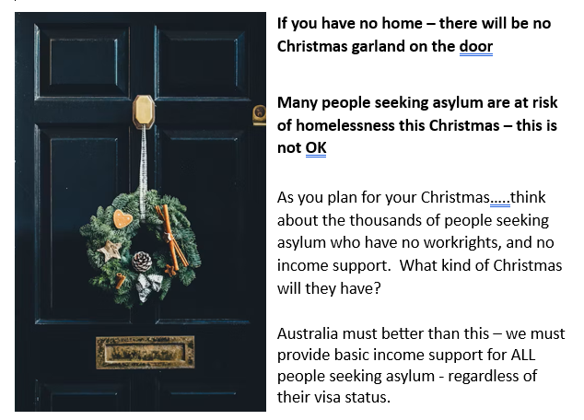

Please help make this happen.

Seasons Greetings

(Your name)………….

(Your address)…………

Option 2: Dear……

Your role is important and powerful.

In every way open to you, please promote a more thoughtful, generous and outward-looking Australian spirit.

One way forward is to legislate a federal Charter of Human Rights for Australia. “Human Rights” is such an abstract term. Essentially, it’s about human kindness. We need it as much as we need sunlight!

Please read and adopt the current draft of the Australian Human Rights Commission for suitable federal legislation. The Joint Parliamentary Committee Report from May 2024 details the evidence given by Victoria, the ACT and Queensland of their successful implementation of state-based human rights legislation.

In 2025 let’s make it easier for people seeking asylum to navigate our bureaucracy. Let’s declare an amnesty for those caught up in our visa systems and end our wasteful expenditure on negativity and rejection. Please work for change and for a humane Australian response. Make our tax dollars build human happiness.

Best wishes for a constructive year ahead!

*Type your name and address here*

Option 3:

Dear …..

Please help make this happen.

Seasons Greetings

(Your name)………….

(Your address)…………

Option 4:

Dear………..

….. the thousands of people seeking asylum who have no work rights, and no income support.

**Many people seeking asylum are at risk of destitution and homelessness this Christmas. This is NOT OK**

Australia must better than this – we must provide basic income support for ALL people seeking asylum - regardless of their visa status.

Will you help to change this in 2025?

Seasons Greetings

(Your name)………….

(Your address)…………

**EMAIL ADDRESSES for MINISTERS and LOCAL MPs**

**Prime Minister:** … Use the contact form: <https://www.pm.gov.au/contact-your-pm>

**Minister Tonyu Burke** [Tony.Burke.MP@aph.gov.au](mailto:Tony.Burke.MP@aph.gov.au)

**Assistant Minister Thistlethwaite** [matt.thistlethwaite.mp@aph.gov.au](mailto:matt.thistlethwaite.mp@aph.gov.au)

**Find details for your local MP here:** <https://www.aph.gov.au/senators_and_members/members>

**EMAIL ADDRESSES for FEDERAL SENATORS in each state.**

**Labor Party Senators are listed in red**

**Just copy and paste into “TO”** section of your email

**Remember to include your NAME and ADDRESS at the end of your email**

**ACT senators**

Labor: [senator.katy.gallagher@aph.gov.au](mailto:senator.katy.gallagher@aph.gov.au);

Independent: [Senator.David.Pocock@aph.gov.au](mailto:Senator.David.Pocock@aph.gov.au)

**NSW senators**

Labor: senator.mcallister@aph.gov.au; senator.oneill@aph.gov.au;

senator.sheldon@aph.gov.au; [senator.ayres@aph.gov.au](mailto:senator.ayres@aph.gov.au);

Greens: senator.faruqi@aph.gov.au; [senator.shoebridge@aph.gov.au](mailto:senator.shoebridge@aph.gov.au)

Liberal: [senator.bragg@aph.gov.au](mailto:senator.bragg@aph.gov.au); senator.kovacic@aph.gov.au; senator.hughes@aph.gov.au; [senator.sharma@aph.gov.au](mailto:senator.sharma@aph.gov.au)

Nationals: [senator.davey@aph.gov.au](mailto:senator.davey@aph.gov.au); senator.cadell@aph.gov.au;

**NT senators**

Labor: [Senator.McCarthy@aph.gov.au](mailto:Senator.McCarthy@aph.gov.au);

Nationals: [senator.nampijinpaprice@aph.gov.au](mailto:senator.nampijinpaprice@aph.gov.au)

**Queensland senators**

Labor: senator.chisholm@aph.gov.au; senator.watt@aph.gov.au; senator.green@aph.gov.au;

Greens: [senator.allman-payne@aph.gov.au](mailto:senator.allman-payne@aph.gov.au); senator.waters@aph.gov.au;

Liberal: senator.scarr@aph.gov.au;

LNP Qld: senator.mcdonald@aph.gov.au;

senator.mcgrath@aph.gov.au; senator.rennick@aph.gov.au;

Nationals: senator.canavan@aph.gov.au;

PHON: [senator.hanson@aph.gov.au](mailto:senator.hanson@aph.gov.au); senator.roberts@aph.gov.au;

**SA senators**

Labor: senator.marielle.smith@aph.gov.au; senator.wong@aph.gov.au; senator.grogan@aph.gov.au; [senator.farrell@aph.gov.au](mailto:senator.farrell@aph.gov.au);

Greens: senator.hanson-young@aph.gov.au; senator.pocock@aph.gov.au;

Liberals: [senator.fawcett@aph.gov.au](mailto:senator.fawcett@aph.gov.au); senator.liddle@aph.gov.au; [senator.mclachlan@aph.gov.au](mailto:senator.mclachlan@aph.gov.au); senator.ruston@aph.gov.au;

[senator.antic@aph.gov.au](mailto:senator.antic@aph.gov.au); senator.birmingham@aph.gov.au;

**Tasmania senators**:

Labor: senator.bilyk@aph.gov.au; senator.carol.brown@aph.gov.au; senator.urquhart@aph.gov.au; senator.polley@aph.gov.au;

Greens: senator.mckim@aph.gov.au; senator.whish-wilson@aph.gov.au

Liberal: [senator.askew@aph.gov.au](mailto:senator.askew@aph.gov.au); senator.chandler@aph.gov.au; senator.colbeck@aph.gov.au; senator.duniam@aph.gov.au;

JLN: [senator.lambie@aph.gov.au](mailto:senator.lambie@aph.gov.au);

IND: [senator.tyrrell@aph.gov.au](mailto:senator.tyrrell@aph.gov.au);

**Victorian senators**

Labor: senator.ciccone@aph.gov.au; senator.stewart@aph.gov.au; senator.walsh@aph.gov.au;

Greens: [senator.hodgins-may@aph.gov.au](mailto:senator.hodgins-may@aph.gov.au);

LNP Coalition: [senator.henderson@aph.gov.au](mailto:senator.henderson@aph.gov.au); senator.hume@aph.gov.au; senator.paterson@aph.gov.au;

NATS: [senator.mckenzie@aph.gov.au](mailto:senator.mckenzie@aph.gov.au);

Independent: senator.thorpe@aph.gov.au; senator.van@aph.gov.au;

Other [senator.babet@aph.gov.au](mailto:senator.babet@aph.gov.au); (UAP)

**WA senators**

Labor: [senator.ghosh@aph.gov.au](mailto:senator.ghosh@aph.gov.au); senator.lines@aph.gov.au; senator.pratt@aph.gov.au; senator.sterle@aph.gov.au

Greens: [senator.steele-john@aph.gov.au](mailto:senator.steele-john@aph.gov.au); senator.cox@aph.gov.au;

Liberal: [senator.brockman@aph.gov.au](mailto:senator.brockman@aph.gov.au); senator.cash@aph.gov.au;

senator.matt.o'sullivan@aph.gov.au; senator.reynolds@aph.gov.au;

senator.smith@aph.gov.au;

IND: Senator.Payman@aph.gov.au;