After 11 YEARS refugees are STILL WAITING for a safe future
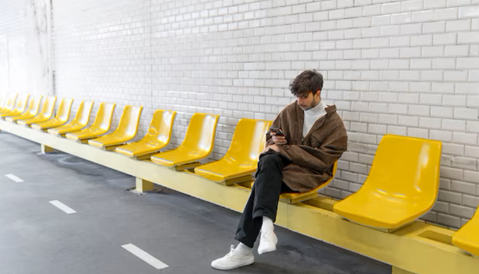
ENOUGH is ENOUGH

People seeking refugee protection need to be treated decently and with dignity

JOIN US at (add date and location for your action here)

Contact for details:

