How would you survive?
WAITING FOR 11 YEARS
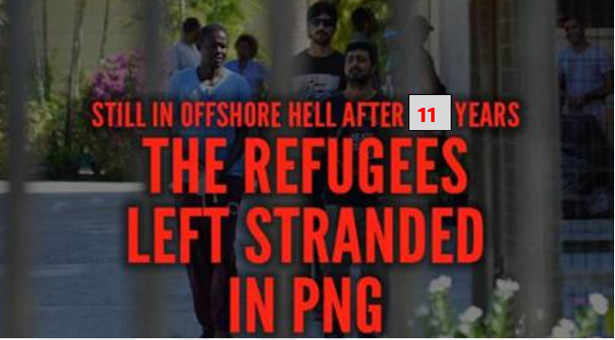
ENOUGH is ENOUGH

Australia has held people in limbo for more than 11 years in PNG, on Nauru, and here in Australia.
- Recognise claims for refugee status
- Bring people to safety in Australia
- Give refugees permanent visas
- End offshore processing

People seeking refugee protection need to be treated decently and with dignity

