How would you survive?
WAITING FOR 11 YEARS
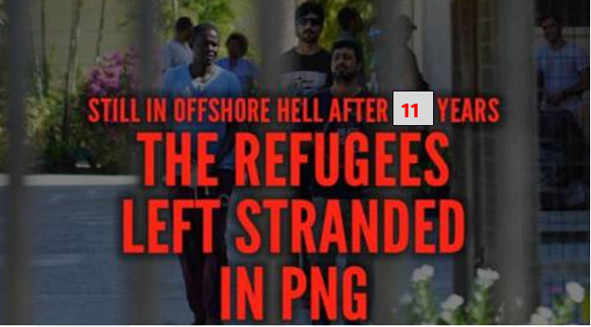
ENOUGH is ENOUGH

Australia has held people in limbo for more than 11 years in PNG, on Nauru, and here in Australia.
- Recognise claims for refugee status
- Bring people to safety in Australia
- Give refugees permanent visas
- End offshore processing

People seeking refugee protection need to be treated decently and with dignity
On 19th July 2013, then Prime Minister Rudd announced that people seeking asylum who arrive by sea would never be allowed to settle in Australia. Between then and June 2023, 3,127 people were sent to PNG and Nauru under this policy. While offshore detention had already been established, the policy to never allow permanent resettlement in Australia, brought a new level of suffering.
This policy has resulted in untold misery for innocent people fleeing war and persecution and has cost Australia over $12 billion. After 11 long years, the punitive consequences of the July 2013 change to refugee policy are still being felt:

- Approximately 50 refugees and asylum seekers are still trapped in PNG. These men (some of whom now have families) are the responsibility of the Australian Government which transported them there. PNG is not providing adequate support, and Australia none.
- The remaining refugees on Nauru were brought to Australia in September last year, but since then people on boats intercepted north of Australia have been taken to Nauru. There are reportedly 100 people detained on Nauru. Detainees in Nauru report conditions to be much the same as during the ‘bad’ old days: difficulty accessing medical care and other services; uncertainty and hopelessness due to lack of information about what’s to happen to them.
- Approximately one thousand people previously held in PNG or on Nauru, who were brought to Australia for medical treatment, are living in the Australian community on insecure bridging visas. They are denied permanent protection and have limited rights to work, education, health care.

When in Opposition, the ALP was critical of how Coalition Governments managed Australia’s regional processing regime. Labor politicians pointed to the lack of transparency, the unacceptable living conditions, the length of time people were being held offshore, and lack of resettlement plans. Yet we see this same regime being continued under the Labor government.
The Albanese Government continues the punitive, and extremely expensive, practice of refusing resettlement and banishing people offshore with no hope for the future simply because they sought safety by sea. The relentless cruelty must stop. The tragedies of the past must not be repeated.
You can take action: Write letters or emails to the Prime Minister, Minister for Home Affairs, and your local MP reminding them that the offshore policy is cruel, and unacceptable. Ideas for your letters can be found at aran.net.au
Emails: use contact forms for the PM https://www.pm.gov.au/contact and Minister O’Neil (contact form: https://rb.gy/ivgye3 ) Minister Giles: andrew.giles.mp@aph.gov.au
Letters & postcards: mail to PO Box 6022, Parliament House, Canberra ACT 2600

