POSTCARD to politicians in EMAIL FORMAT
You can email a postcard to politicians – just choose the picture you prefer, and copy text below – or your own words of course
Find your local federal MP here See contact details for MPs and Senators here.
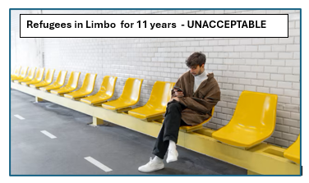

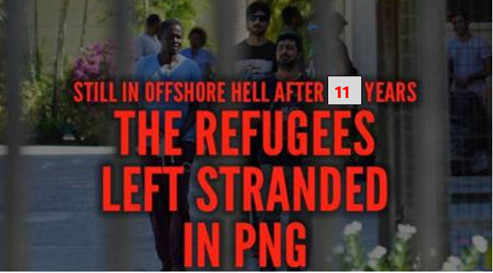

Dear

11 Years of Trauma = 11 Years Too Long - ENOUGH IS ENOUGH

- Remove the ban on resettlement in Australia: permanent visas NOW
- Evacuate refugees abandoned in PNG
- Refugees off Nauru
- End the secrecy about Australia’s cruel offshore detention
- End offshore processing

(add additional comment if you wish)

(your name)
(your address)

