END OFFSHORE DETENTION
Stop the cruelty

END LABOR’S SHAMEFUL LEGACY:
CRUEL REFUGEE
POLICIES
$$$ billions

spent on

10 YEARS
of
Australian-sponsored CRUELTY
in PNG and Nauru

Bring the last 80 refugees here to safety

10 YEARS

of
Australian-sponsored
CRUELTY
in PNG and Nauru

Bring the last 80 refugees
here to safety

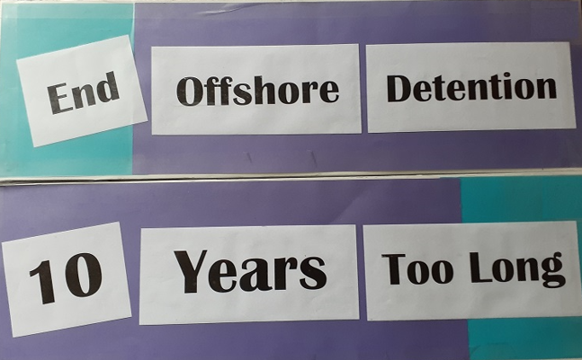
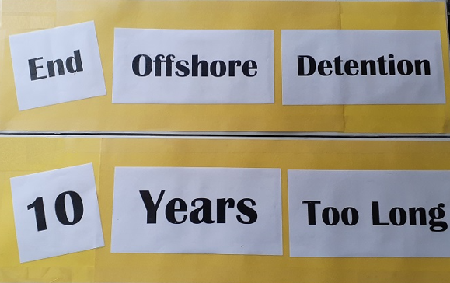
10 years TOO bloody LONG
Refugees on PNG
need safe futures
Bring them here

Permanent visas for ALL refugees

Australia has ABANDONED refugees in PNG
Bring them here NOW

REFUGEES held for 10 years
in PNG and on Nauru
OFFER RESETTLEMENT HERE

Refugees Off PNG - NOW

10 years of suffering must end
Refugees Off PNG

IT’S TIME for CHANGE
Refugees Off PNG – NOW
Australia is shirking responsible for refugees and people seeking asylum held in PNG for 10 years
END THE CRUELTY
Give them a safe and secure future

Justice for Refugees

10 years in limbo
10 years of suffering and trauma
10 years separated from loved ones
10 years of FAILED REFUGEE POLICY MUST END NOW
Permanent Visas NOW

