10 YEARS TOO LONG
It’s time to END THE TRAUMA and give refugees permanent visas
It is now 10 years since then Prime Minister Kevin Rudd announced that no refugee arriving by boat on or after 19 July 2013 would be resettled permanently in Australia. This was a new policy low point, with the devastating effect of dashing hopes for a safe and secure future for the 3,127 people who were sent to ‘offshore detention’ in either PNG or Nauru after that fateful date.
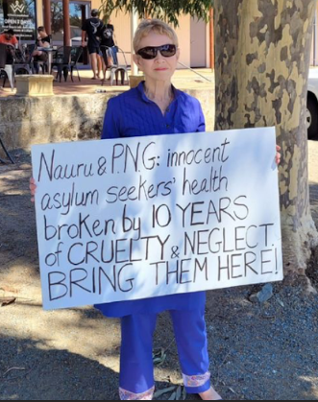
All of these people, including 122 children held on Nauru, have suffered significant harm in extremely harsh conditions. 14 people have died as a result of offshore detention, due to lack of appropriate medical and mental health care, one person was murdered. Several damning reports by the UN Human Rights Commissioner and the Australian Human Rights Commission have called on successive Australian governments to end the offshore arrangements.
Now, after 10 long years of suffering there are still around 1300 people in limbo, with no pathway to safe resettlement:
- people held on Nauru have at last been brought to Australia
- BUT around 80 people are still in Papua New Guinea, and some of these people are very unwell
- around 1,150 people are in Australia, having been medically evacuated from either PNG or Nauru. They remain in community detention or are living on Final Departure Bridging Visas. Under the current policy these people are not allowed to settle permanently in Australia
What needs to happen now?
- The Albanese government must allow all those still in PNG the option of being transferred to Australia while resettlement pathways are confirmed, including here in Australia.
- Those who choose transfer must be allowed to live in the community (not be held in locked detention) and given work rights, medical care and the supports they need.
- Provide all refugees in Australia with the right to a permanent visa.
- All people seeking asylum in Australia need a fair process to determine their refugee status – the Fast Track process is unfair.
- The offshore detention regime needs to be ended, and the $400m currently allocated redirected to supporting resettlement.
- Australia needs to lift the ban on resettling refugees stranded in Indonesia – many have family members and connections to refugee communities in Australia.

You can make a difference – take action NOW!

Contact politicians – they need to know you are not satisfied with the current situation and call on them to change the cruel policies and end the suffering.
Arrange a meeting with your local MP and Federal Senators for your state if they are Labor, Greens or a progressive independent MP. Find senators here : bit.ly/SelectedSenators
Write to or email your local MP (if Labor, Greens or a progressive Independent) and senators in your state. Find local MPs https://www.aph.gov.au/Senators_and_Members/Members and email contacts for Labor, Greens or progressive Independent senators can be found here.
- See general tips here for emailing politicians bit.ly/TipsMeetingsLetterswithMPs
- Post a postcard to your local MP (if Labor, Green or a progressive independent) You can download from here bit.ly/PostcardsRefugeesOff
Display a placard:
- Refugees Off PNG - NOW
- Australia has abandoned refugees in PNG - Bring them here
- 10 years of suffering must end NOW
- Permanent Visas for ALL refugees in Australia
- Fair process for assessing refugee status
- End offshore detention
- Open resettlement to refugees stranded in Indonesia
- Justice for Refugees
Share social media posts from 3 July 2023 on the ARAN Facebook page https://www.facebook.com/AustralianRefugeeActionNetwork/
- Use the hashtags: #RefugeesOffPNG #TenYearsTooLong #PermanentVisas
Join an activist group: To find out about groups you can join, email ARAN austrefugeenetwork@gmail.com

