Refugee Sector Letter Kit

Supported by ARAN, RAR, GFR, & NARN
Issue for April 2023
Postcards - Evacuate Refugees from PNG and Nauru

Available to download at –
- https://aran.net.au/resources/letter-writing/
- https://ruralaustraliansforrefugees.org.au/write-a-letter

Included in this kit is the information you need to create your own letters or use the proformas

- Guide and Background notes prepared by ARAN’s Letter Writing Network.
- Postal Addresses for MPs and Senators
- Email addresses for MPs and Senators
- A proforma letter that you can copy (and personalise) to send by post or email.

Personalised letters are best –

- You might like to use the AIDA principle

  - A - Attention - grab the recipient's attention. Say something positive about the reader that is directed towards the focus of your letter. Stimulate the recipient's curiosity
  - I - Interest&Information- encourage the recipient to read on.
  - D - Desire - Getting the reader to want to do what you are seeking - in their interest to do so.
  - A - Action- inform the reader of the action you want them to take.

~~~~~~~~~~~~~~~~~~~~~~~~~~~~~~~~~~~~~
Regards,
The ARAN Letter Writing Network
austrefugeenetwork@gmail.com

Background Notes:

Why it is Important to Write about this issue

The Australian government acknowledges that a number of asylum seekers and refugees have been stranded offshore in PNG and Nauru far longer than can reasonably be expected.

As of 14/02/2023, people seeking asylum and refugees have been kept offshore for 3,500 days.

- In September 2021, the Minister for Home Affairs signed a new deal with Nauru to keep an ongoing form of asylum seeker processing centre on the island.
- On 6 October 2021, the Australian Government passed responsibility for the remaining 124 men on PNG to the PNG Government.

- There have been 14 deaths from offshore detention Australia is responsible for. Another death now would be a preventable death.

Arecent Senate Inquiry recognised that this has resulted in significant personal costs, including physical and mental health costs, that cannot be allowed to continue, and urged the government to urgently consider all available options to remove asylum seekers and refugees from PNG and Nauru.
The Australian government,while affirming its commitment to deterringdangerous boat journeys, has also affirmed that unauthorised maritime arrivals should only be detained offshore for ‘a very short period of time until a third-country settlement arrangement can be put in place’.

Resettlement Options

- Some of the men are waiting for resettlement in Canada or NZ - they may be still facing years of waiting.
- Approx 75 of the men in PNG and Nauru have no resettlement pathways - they cannot be resettled in PNG or on Nauru - they have no hope for the future - they have no pathway to safe resettlement
- 13 men in PNG are too unwell to engage in any process for resettlement, and most are isolating themselves and not communicating with others.

Financial Costs

- The Australian government has spent billions keeping these men on Nauru and PNG - depriving them of hope - now their situation is desperate - we have robbed them of their youth / wasted lives
- The Albanese government has just contracted a company that operates US prisons to maintain the arrangements on Nauru - at a cost of $$420m for 3 years

Key Points

- Around 150 refugees are in limbo on Nauru & PNG - they have been held there for 10 YEARS.
- Many of the men are in need of urgent medical care and mental health support.
- Years of suffering and neglect must be brought to an end.
- Some of the men have no resettlement pathways - they cannot be resettled in PNG or on Nauru - they have no hope for the future

Sources

- Migration Amendment (Evacuation to Safety) Bill 2023 - Senate Legal and Constitutional Affairs CommitteeReporthttps://www.aph.gov.au/Parliamentary_Business/Committees/Senate/Legal_and_Constitutional_Affairs/EvactoSafety2023/Report
- Evacuate PNG and Nauru Working Group - national_refugee_network@amnesty.org.au

This month we are providing you with Printable Postcards.
Of course you can still use the information provided to write your own letters if you prefer.

Addresses for your postcards:
- The Prime Minister
The Hon Anthony Albanese, Prime Minister
PO Box 6022, House of Representatives, Parliament House, Canberra ACT 2600

- Clare O’Neil, Minister for Home Affairs
The Hon Clare O’Neil, Minister for Home Affairs
PO Box 6022, House of Representatives, Parliament House, Canberra ACT 2600

- Andrew Giles, Minister for Immigration, Citizenship, Migrant Services & Multicultural Affairs
The Hon Andrew Giles, Minister for Immigration, Citizenship, Migrant Services & Multicultural Affairs
PO Box 6022, House of Representatives, Parliament House, Canberra ACT 2600

You may like to send a postcard to your local MP or Senators for your state.

- the address for all MPsisPO Box 6022, House of Representatives, Parliament House, Canberra ACT 2600

- the address for all SenatorsisPO Box 6100, House of Representatives, Parliament House, Canberra ACT 2600

Find electorate postal and email addresses for your local MP:https://www.aph.gov.au/senators_and_members/members

Email addresses for MPs and Senators - https://aran.net.au/resources/letter-writing/

*** Links for Online Actions ***

- Email your MP to Evacuate PNG and Nauru - https://action.asrc.org.au/evacuate-png-nauru
- Email your MP to Increasing Australia's annual Refugee Intake - https://action.refugeecouncil.org.au/refugee_intake_email_your_mp

On the next 2 pages are printable postcards - Evacuate PNG and Nauru

You can print these on your home printer. The template will give you 4 postcards.

Suggested paper - A4 - 120gsm to 160gsm
If you need to use normal 80gsm A4 paper, you might need to post in an envelope as the paper is thin.

In your printer settings:
- Select“Duplex”-“Two-sided printing” - “Print on both sides”.
  - Select “Flip on shortedge”.
- SelectLandscape

- Select pages 5-6

- Print

Or …. take the file to your local Office Copy Centre. - Explain that you only want Pages 5-6 printed

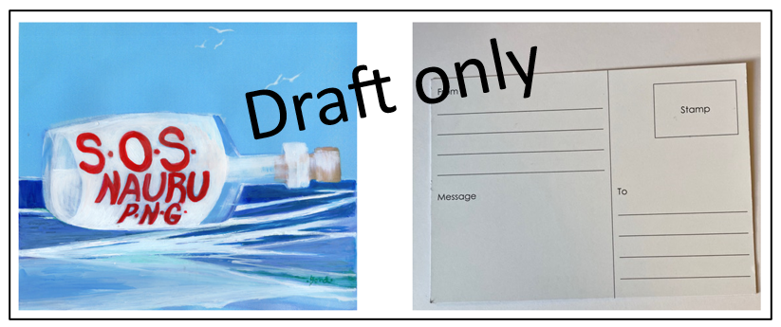
Also available - from Queenscliff RAR
SOS Nauru and PNG Postcards
- Orders can be placed with QRAR - info@queenscliffrar.org
- Or by mail … C/- PO Box 52, QUEENSCLIFF VIC 3225
- Queenscliff RAR can have a batch printed and sentto you
- Cost of printing is $188 for 500 cards … plus postage.

- Please do not reproduce this artwork without personal permission of artist

