Suggested slogans for placards -
choose font and set up placards as you wish !

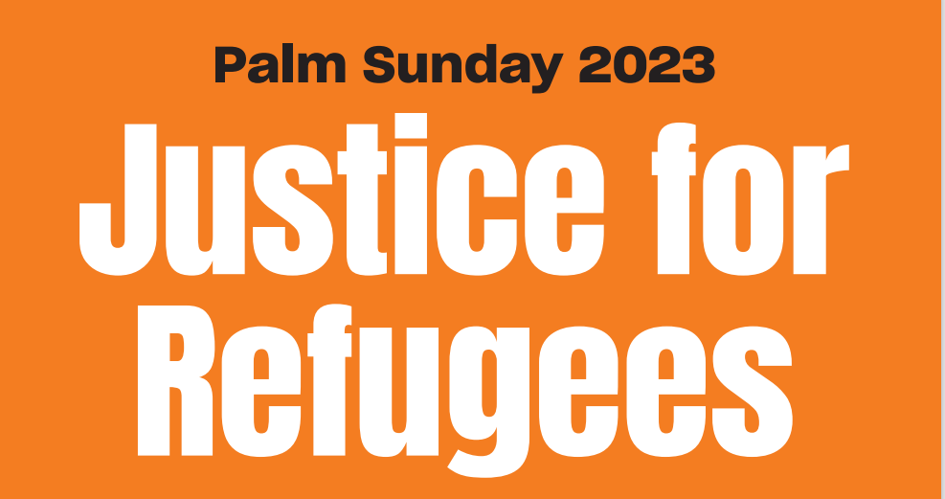
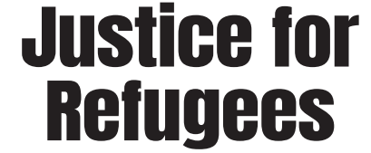

PERMANENT VISAS
FOR ALL REFUGEES

12,000 PEOPLE STILL IN LIMBO

ENOUGH !

PERMANENT VISAS
FOR ALL REFUGEES

NOBODY LEFT
BEHIND

PERMANENT VISAS
FOR ALL REFUGEES

10 YEARS IN LIMBO
ENOUGH!

PERMANENT VISAS FOR ALL REFUGEES!

12,000 PEOPLE STILL IN LIMBO

10 YEARS TOO LONG

10 YEARS ON BRIDGING VISAS

ENOUGH!

PERMANENT VISAS FOR ALL REFUGEES
JUSTICE FOR REFUGEES

ABOLISH
‘FAST TRACK’ PROCESS!

FAIR PROCESSING NOW!

