This Information Kit for Churches includes:
- Context – why Palm Sunday is an important day to call for justice for refugees
- How your church can help to promote Palm Sunday activities
- Display a Justice for Refugees BANNER – see order form below
- Ideas for sermons and prayers for Palm Sunday
- A link to a Resource for use in schools
- Further background information on current refugee issues
Palm Sunday is a time to reflect on the plight of refugees, forced to flee their homes and their homeland because of war and/or political oppression.

Congregations might like to include a focus on refugees in their services, and the actions they can take to call for Justice for Refugees. A selection of prayers for refugees that may be adapted for use in congregations – see link below.

Poster for Palm Sunday Walk for Justice

Leaflet - Palm Sunday Walk for Justice
WHY FAITH COMMUNITIES CALL FOR JUSTICE FOR REFUGEES ON PALM SUNDAY
The call to show loving kindness and care for our neighbours, to welcome the stranger, and to uphold the worth and dignity of each person, is central to our Christian beliefs and practices. At the same time, advocacy may be needed as part of our response to the lived experience of the vulnerable and marginalised. It may also require a challenge to unjust systems that perpetuate inequity and disadvantage. Christians may contribute to respectful public dialogue with policy makers so that constructive change can happen.
Palm Sunday each year is an occasion to bear witness to the priority of compassion and to call for justice for refugees and asylum seekers. It is also a time to celebrate the contribution that so many refugees have made to Australian society in a wide range of endeavours. It is a time to stand together.
Across Australia, in capitals cities and in local communities, there will be actions calling for Justice for Refugees, and Permanent Protection for ALL Refugees who are here in Australia. For information about where local actions will be held, and other more general information about Palm Sunday, including a leaflet and poster – go to https://aran.net.au/palm-sunday-2023/
HOW YOUR CHURCH HELP TO PROMOTE PALM SUNDAY ACTIVITIES
- Make mention of the need for Justice for Refugees in your services on Palm Sunday
- Make sure the poster and leaflet is displayed and available in your church
- Consider ordering a Justice for Refugees banner for display outside your church (Possibly on a permanent basis) – see below details for ordering a banner from the Refugee Advocacy Network
- Encourage your members to an action in their local area if there is one – see https://aran.net.au/palm-sunday-2023/#listingevents
- For those who are unable to attend events on the day, there will be an online action they can take – see https://aran.net.au/palm-sunday-2023/#faithcomm
IDEAS FOR SERMONS AND SERVICES ON PALM SUNDAY
Prayers
- Prayer by the Anglican Diocese of Melbourne: https://aran.net.au/wp-content/uploads/2022/03/Palm-Sunday-Prayer.pdf
- Commongrace Prayers: https://www.commongrace.org.au/asylum_pray
Link to video clip - Rev. Dr. Katherine Rainger, Holy Covenant Anglican Church (Canberra) calling on people to attend the Palm Sunday rallies for Justice for Refugees in whichever town or city they live. https://www.youtube.com/watch?v=S4lyyqjwnOw
Notes for Sermons
The Gospel stories of the entry of Jesus to Jerusalem on a donkey, on what we now call Palm Sunday, is well known. The crowds shouted, ‘Hosanna to the Son of David! Blessed is he who comes in the name of the Lord! Hosanna in the highest heaven!’ (cf Psalm 118:25-26). The crowds recognised the event as fulfilment of ancient prophesy (Zechariah 9.9). “Rejoice greatly, Daughter Zion! Shout, Daughter Jerusalem! See, your king comes to you, righteous and victorious, lowly and riding on a donkey, on a colt, the foal of a donkey”. This king would be the non-violent king, a king of peace: "He will cut off the chariot from Ephraim and the war horse from Jerusalem; and the battle bow shall be cut off, and he shall command peace to the nations" (9.10).
Thus it was, that Jesus chose to ride "the most unthreatening, most un-military mount imaginable: a female nursing donkey with her little colt trotting along beside her" (John Dominic Crossan). In their compelling book, The Last Week: What the Gospels Really Teach About Jesus' Last Days in Jerusalem, Crossan and Borg argue that two processions entered Jerusalem on that first Palm Sunday. Every year, the Roman governor of occupied Judea would ride up to Jerusalem from his coastal residence in the west, specifically to be present in the city for Passover - the annual Jewish festival that swelled Jerusalem's population from its usual 50,000 to at least 200,000. It was a politically volatile time, with the risk of riots as the Jewish people recalled Passover and the ancient victory over Egypt, and fanned the flames of hope for their liberation from Roman occupation. Pilate brought with him soldiers and cavalry to reinforce the imperial garrison in Jerusalem. It made an impressive military procession, designed to intimidate the Jewish people and remind them Rome was in charge, and watching.
The entry of Jesus into Jerusalem was a carefully staged counter-procession to the pomp and power of the Roman empire. Each proclaimed two very different and contrasting visions of how this world can and should be: the kingdom of God versus the kingdoms and the powers of this world. The former is about justice and the end of violence. The latter is about domination and exploitation.
The Palm Sunday Walk for Refugees is a contemporary procession through city streets. Some people will hold signs and banners, some will sing songs, some will call out for compassion and justice. Some onlookers may pause to look for a moment as the procession passes by, and then go about their day. Some will wonder what a group of Christians and concerned citizens can do to change Government policies and practices and put an end to the profiteering of private companies managing offshore facilities that detain vulnerable, traumatised people. Yet those who join the Palm Sunday ‘procession’ remain committed to seeking compassionate and just ways to respond to refugees and asylum seekers.
As we reflect on the plight of refugees, forced to flee their homes and, for many, their homeland, we can see the terrible consequence of war and conflict, and military might. Let us again turn our attention to the way of Jesus, Prince of Peace, and to justice and the end of violence. Let us follow the example of Jesus in offering compassionate care to the most vulnerable in our global village.
BACKGROUND INFORMATION on REFUGEE ISSUES
Justice for Refugees means:
> Permanent visas and family reunion for ALL refugees in Australia
> Fair and timely assessment of all claims for refugee status
> Health care, work rights, income support, and access to education for all those seeking asylum
> Releasing ALL refugees from detention
> Offering resettlement here for refugees still in PNG, on Nauru, and in Indonesia
> Ending offshore processing and detention
> Increasing the humanitarian intake of refugees

Update on recent announcement regarding permanent visas:

We welcome the news, that around 19,000 refugees who have been in limbo for 10 years on temporary TPVs and SHEV visas will now be able to apply for permanent visas and will also be able to apply for family reunion. These refugees have been separated from loved ones for many years, and family reunification is an essential element of the resettlement process.

However, there are around 12,000 people who are having their claims for refugee status processed under the flawed so-called ‘Fast Track System’. After 10 years most these people are still waiting for their status to be decided, and many have been unfairly refused. There is no doubt that many of these people are owed protection as refugees - they need natural justice and a rapid pathway to permanency. The announcement by the government on 13 February has no effect for these people, they remain in limbo.

Display a Justice for Refugees BANNER

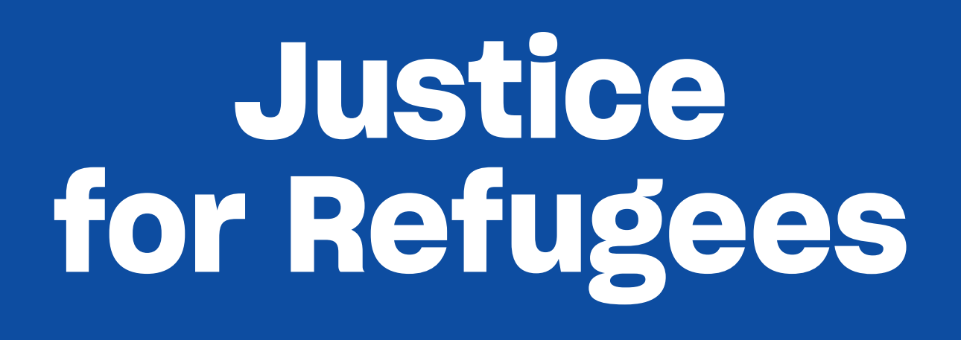

The banner will be 2m wide and 70cm deep – with ropes and eyelets for easy hanging or carrying.

Refugee Advocacy Network has placed a bulk order for vinyl Justice for Refugees banners for use by local groups, local churches, schools etc.

To order a banner send the following information to info@refugeeadvocacynetwork.org.au

Please use the Subject line: Order for banner

Name of your group/church/organisation

Name of contact person

Email for contact person

Mobile for contact person

Number of banners required

Delivery Address

Payment by direct deposit to Refugee Advocacy Network (RAN) Bendigo Bank: BSB: 633 000 Account No: 140311184 Reference= Name of your group
Option 1 – Prepayment: I have made a payment of $50 to the RAN account Yes/No
Option 2– Payment on delivery: I will make a payment of $50 to the RAN account once the banner is received Yes/No
Please indicate clearly which payment option is relevant Note: pre-payment is much preferred!

Send this order form with all requested details to Marie at info@refugeeadvocacynetwork.org.au to secure your order.

