Refugee Sector Letter Kit
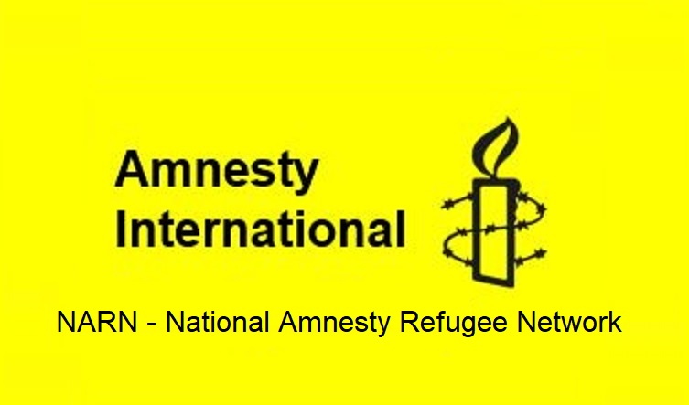

Issue for December 2022
Restore Status Resolution Support Service (SRSS) Supported by ARAN, RAR, GFR, & NARN
Restore Safety Net Income Support

Available to download at –
- https://aran.net.au/resources/letter-writing/
- https://ruralaustraliansforrefugees.org.au/write-a-letter

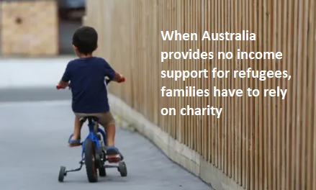

Included in this kit is the information you need to create your own letters or use the proformas

- Guide and Background notes prepared by ARAN’s Letter Writing Network.
- Postal Addresses for MPs and Senators
- Email addresses for MPs and Senators
- A proforma letter that you can copy (and personalise) to send by post or email.

Personalised letters are best –

- You might like to use the AIDA principle

  - A - Attention - grab the recipient's attention. Say something positive about the reader that is directed towards the focus of your letter. Stimulate the recipient's curiosity
  - I - Interest & Information - encourage the recipient to read on.
  - D - Desire - Getting the reader to want to do what you are seeking - in their interest to do so.
  - A - Action - inform the reader of the action you want them to take.

~~~~~~~~~~~~~~~~~~~~~~~~~~~~~~~~~~~~~
Regards,
The ARAN Letter Writing Network
austrefugeenetwork@gmail.com

BACKGROUND INFORMATION:
Restore Status Resolution Support Service (SRSS) - Restore Safety Net Income Support

There is an urgent need to restore a basic financial safety for people on bridging visas who are living in the Australian community.

People on bridging visas are currently denied access to most of Australia’s social safety net, receiving little or no financial or housing support. Some people on bridging visas are also denied the right to work. Consequently, many thousands are living in poverty and destitution; many are homeless.

The Status Resolution Support Service The (SRSS) is a federal government program intended to assist people who are waiting for the government to assess their refugee application. The program provides a basic living allowance (typically 89% of the JobSeeker allowance), very limited casework support and sometimes access to torture and trauma counselling.

Between 2015 and 2022, Coalition governments cut the SRSS Program spending by 94%. Eligibility conditions were made so stringent that few people can qualify to receive SRSS. Without this support, thousands of people who are living with trauma are struggling to live in Australia, reliant on community charities. Many of these people have been subject to offshore processing or community detention. Many are still developing English language skills, have complex health challenges, or have caring responsibilities.

The Refugee Council of Australia has said: ‘Communities across Australia are witnessing the impacts of destitution and homelessness among bridging visa holders as a direct result of changes since 2017 to eligibility to SRSS program support.’

ASRC chief executive Kon Karapanagiotidis: ‘It’s time to right the wrongs of the past decade, not continue the status quo of unfairness by denying refugees and people seeking asylum access to mainstream social support and a safety net.

There is an urgent need for an immediate injection of funds to the SRSS Program budget. The additional budget allocation would be relatively minor but the impact it would have on families and individuals would be great.
The ALP National Platform outlines the new Government’s plan related to this issue. The Platform states the ALP’s commitment to: “Inclusion of means-tested access to social services, including income support, migration advice, crisis housing, healthcare, mental health support, and community, education and English as a Second Language support during the assessment of the claim for protection.”

https://www.refugeecouncil.org.au/letter-to-parliamentarians-regarding-financial-support-for-srss/
https://alp.org.au/media/2594/2021-alp-national-platform-final-endorsed-platform.pdf
https://www.refugeecouncil.org.au/thousands-of-people-seeking-asylum-living-in-poverty/

Key Asks
- Restore SRSS support to all people awaiting determination of their refugee status

- Ensure that all refugees and people seeking asylum have the right to work, to study, and have access to income support and medical care.

Addresses for your letters:

- The Prime Minister
Prime Minister
PO Box 6022, House of Representatives, Parliament House, Canberra ACT 2600

You cannot email the PM. Use the following link to the PM’s Contact Form.
https://www.pm.gov.au/contact-your-pm

- Clare O’Neil, Minister for Home Affairs
The Hon Clare O’Neil
Minister for Home Affairs
PO Box 6022, House of Representatives, Parliament House, Canberra ACT 2600

Email: Clare.Oneil.MP@aph.gov.au

Or use the Contact Form: https://www.aph.gov.au/Senators_and_Members/Contact_Senator_or_Member?MPID=140590

- Andrew Giles, Minister for Immigration, Citizenship, Migrant Services & Multicultural Affairs
The Hon Andrew Giles,
Minister for Immigration, Citizenship, Migrant Services & Multicultural Affairs
PO Box 6022, House of Representatives, Parliament House, Canberra ACT 2600

Email: Andrew.Giles.MP@aph.gov.au

Or use the following link to the Contact Form:
https://www.aph.gov.au/Senators_and_Members/Contact_Senator_or_Member?MPID=243609

You may also like to send a copy of your email to:

- Your local MP - https://www.aph.gov.au/Senators_and_Members/Members
- Greens Senator Nick McKim senator.mckim@aph.gov.au

Canberra Postal Address for all Senators
PO Box 6100
Senate,
Parliament House
Canberra ACT 2600

Canberra Postal Address for all MPs
PO Box 6022
House of Representatives
Parliament House
Canberra ACT 2600

Find electorate postal and email addresses for your local MP: https://www.aph.gov.au/senators_and_members/members

Email addresses for MPs and Senators - https://aran.net.au/resources/letter-writing/

Email addresses for all Senators are on the next page

You may also send a copy of your letter to Senators in your state:

Email Addresses for ALL Senators - updated September 2022

Email addresses for all ACT senators - ready to copy and paste into “TO” section of your email:
senator.katy.gallagher@aph.gov.au; Senator.David.Pocock@aph.gov.au

Email addresses for all NSW senators - ready to copy and paste into “TO” section of your email:
senator.ayres@aph.gov.au; senator.bragg@aph.gov.au; senator.cadell@aph.gov.au;
senator.davey@aph.gov.au; senator.faruqi@aph.gov.au; senator.hughes@aph.gov.au;
senator.mcallister@aph.gov.au; senator.molan@aph.gov.au; senator.oneill@aph.gov.au;
senator.payne@aph.gov.au; ; senator.sheldon@aph.gov.au; senator.shoebridge@aph.gov.au

Email addresses for all NT senators - ready to copy and paste into “TO” section of your email:
Senator.McCarthy@aph.gov.au; senator.nampijinpaprice@aph.gov.au

Email addresses for all Queensland senators - ready to copy and paste into “TO” section of your email:
senator.canavan@aph.gov.au; senator.chisholm@aph.gov.au; senator.green@aph.gov.au;
senator.hanson@aph.gov.au; senator.mcdonald@aph.gov.au; senator.mcgrath@aph.gov.au;
senator.rennick@aph.gov.au; senator.roberts@aph.gov.au; senator.scarr@aph.gov.au;
senator.stoker@aph.gov.au; senator.waters@aph.gov.au; senator.watt@aph.gov.au;

Email addresses for all SA senators - ready to copy and paste into “TO” section of your email:
senator.antic@aph.gov.au; senator.birmingham@aph.gov.au; senator.farrell@aph.gov.au;
senator.fawcett@aph.gov.au; senator.grogan@aph.gov.au; senator.hanson-young@aph.gov.au;
senator.liddle@aph.gov.au; senator.mclachlan@aph.gov.au; senator.pocock@aph.gov.au;
senator.ruston@aph.gov.au; senator.marielle.smith@aph.gov.au; senator.wong@aph.gov.au;

Email addresses for all Tasmania senators - ready to copy and paste into “TO” section of your email:
senator.askew@aph.gov.au; senator.bilyk@aph.gov.au; senator.carol.brown@aph.gov.au;
senator.chandler@aph.gov.au; senator.colbeck@aph.gov.au; senator.duniam@aph.gov.au;
senator.lambie@aph.gov.au; senator.mckim@aph.gov.au; senator.polley@aph.gov.au;
senator.tyrrell@aph.gov.au; senator.urquhart@aph.gov.au; senator.whish-wilson@aph.gov.au;

Email addresses for all Victorian senators - ready to copy and paste into “TO” section of your email:
senator.babet@aph.gov.au; senator.ciccone@aph.gov.au; senator.henderson@aph.gov.au;
senator.hume@aph.gov.au; senator.mckenzie@aph.gov.au; senator.paterson@aph.gov.au;
senator.rice@aph.gov.au; senator.stewart@aph.gov.au; senator.thorpe@aph.gov.au;
senator.van@aph.gov.au; senator.walsh@aph.gov.au; senator.white@aph.gov.au

Email addresses for all WA senators - ready to copy and paste into “TO” section of your email:
senator.brockman@aph.gov.au; senator.cash@aph.gov.au; senator.cox@aph.gov.au;
senator.dodson@aph.gov.au; senator.lines@aph.gov.au; senator.matt.o'sullivan@aph.gov.au;
senator.pratt@aph.gov.au; senator.reynolds@aph.gov.au; senator.small@aph.gov.au;
senator.smith@aph.gov.au; senator.steele-john@aph.gov.au; senator.sterle@aph.gov.au

NOTE: If you are sending an email be sure to include your NAME and ADDRESS

Email addresses for MPs and Senators - https://www.aph.gov.au/Senators_and_Members/Members

The Subject line of your email could be - CALL TO ACTION - Restore Status Resolution Support Service (SRSS)

Restore Status Resolution Support Service (SRSS) - Restore Safety Net Income Support
Sample Letter - please write using your own words

Dear Minister O’Neil

Earlier this year, I was extremely pleased to hear an Australian government say it would look after the disadvantaged, the vulnerable, and leave no one behind. Labor restored hope that had been lacking for a decade. But people cannot pay the bills or buy food with ‘hope’.

Among the most vulnerable in our community are people waiting to have their refugee status resolved.

During the last 10 years, inhumane policies were introduced. Policy changes cruelly restricted eligibility for Status Resolution Support Service (SRSS) to such an extent that most people awaiting protection decisions are now considered not eligible for income and support, even though the purpose of the SRSS Program, administered on behalf of the Department of Home Affairs, is to support people who have no other form of income. The payments are meagre enough, capped at just 89% of the JobSeeker rate. Most people who are able to find sufficient work to support themselves and their families do so, but there are times when people need a safety net - in times of sickness, or between casual jobs.

Sadly, since 2016, the cut to the SRSS Program has been staggering … 94% cut since 2016 … leaving many people in absolute destitution.

Approximately 30,000 people currently have no safety net as they await decisions on their protection application. Many are homeless, destitute, with no means to support themselves and their families, completely reliant on the community.

Some state governments have provided funds to help support people seeking asylum who cannot support themselves in employment. However, this state funding is not consistent, and in Victoria (which has a high population of people seeking asylum) it has been discontinued. We know that many charities are stretched, and unable to provide the level of support that families need.

Though I knew that the October budget would be challenging, I had really hoped to see the Government take measures to alleviate what is a very real humanitarian crisis in our own country.

This is a matter of urgency. I urge you to please take action immediately.

- Restore SRSS support to all people awaiting determination of their refugee status

- Ensure that all refugees and people seeking asylum, including those in appeal processes, have the right to work, to study, and have access to income support and medical care

Yours sincerely

Your name
Your address

