This Christmas thousands of refugees in Australia remain unnecessarily separated from their families.

This must change.

Give refugees permanent visas and allow them to reunite with their families.

Australia’s cruel treatment of refugees must end.

Make the change now.

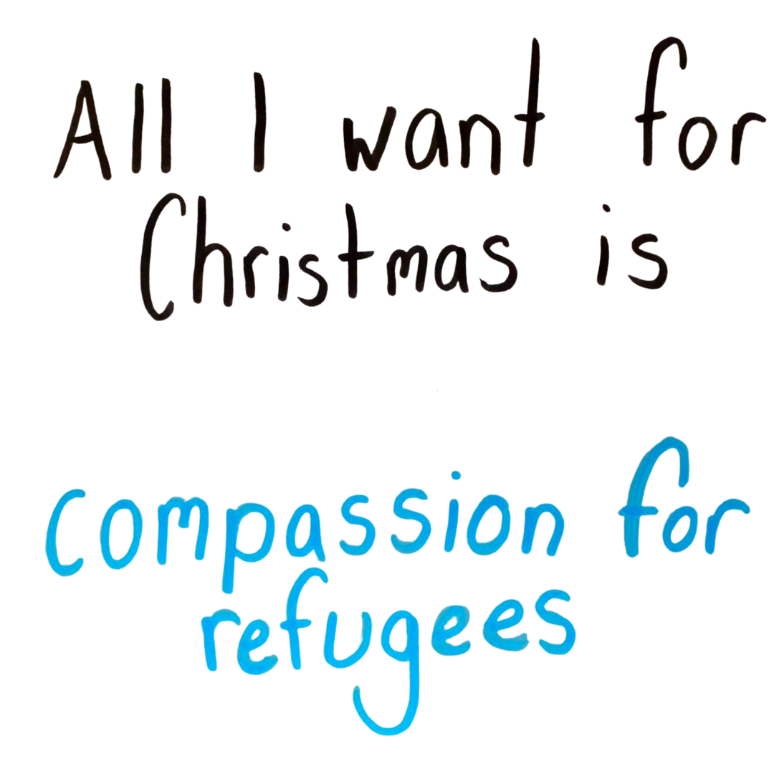

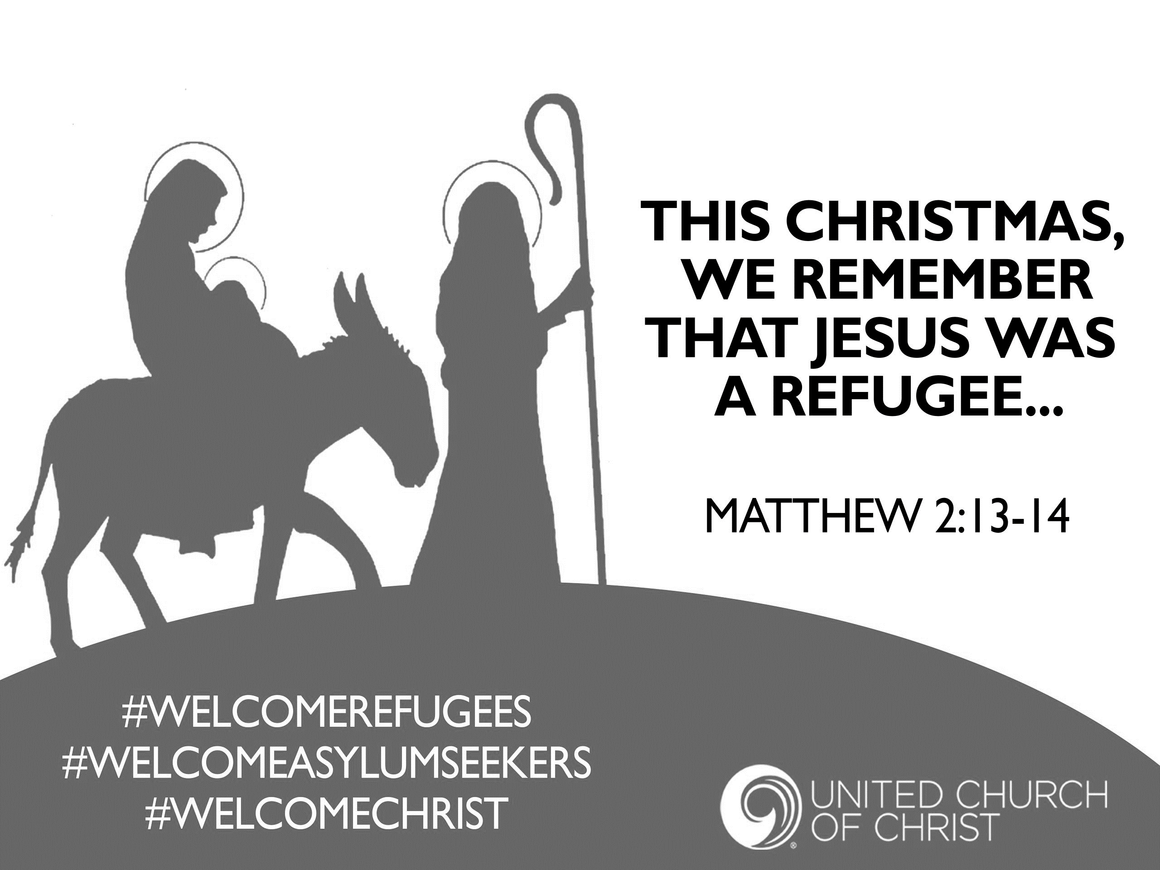

To:

From :