Christmas email to politicians - Family Reunion for Refugees

You might want to encourage your friends and family to take this small action for refugees.
Just Copy and Paste the picture and text below into your email or write your own message.

Send to:
- Prime Minister - copy into contact form https://www.pm.gov.au/contact-your-pm
- Minister for Home Affairs Karen.Andrews.MP@aph.gov.au
- Minister for Immigration Alex.Hawke.MP@aph.gov.auand
- your local MP Find your federal MP here
- all your State Senators - find the email contacts for your federal senators - by state - on this page: https://aran.net.au/resources/letter-writing/

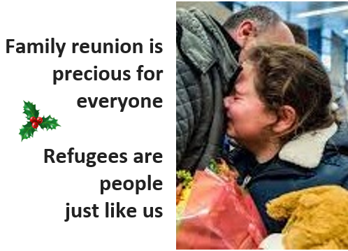
Dear

This Christmas thousands of refugees in Australia are unnecessarily separated from their families and loved ones.

This could easily be changed. Give refugees permanent visas - not Temporary Protection Visas and SHEVs – and allow them to bring their families here.

Australia’s cruel treatment of refugees must end.

Make the change now.

(your name)
(your address)

