8 YEARS & $8 billion
state-sponsored cruelty in PNG and Nauru

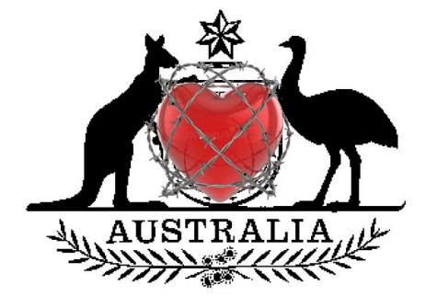

Release and resettle Australia’s refugees

