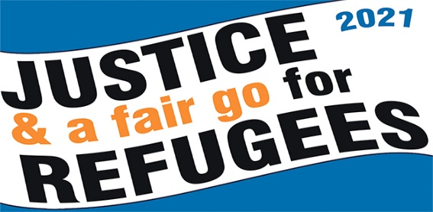
A call for Justice and a Fair Go for Refugees
Media Release
Date: insert date

People will gather across the nation on Palm Sunday, 28 March 2021.

The annual Palm Sunday social justice event has a rich history. While the focus has been on different issues over time, it has now, for almost a decade, focussed on Australia’s harsh refugee policies. Hundreds of organisations have endorsed the Palm Sunday “Walk for Justice and a Fair Go for Refugees” rallies, as thousands of Australians add their voices to the call for decency, compassion and fairness.

In capital and regional cities, and in small country towns, Australians will hold rallies and vigils calling on the Government to show justice to refugees. Many participants will gather for church services before joining the rallies. Faith Leaders are all represented, Jewish, Hindu, Anglican, Catholic, Islamic, Buddhist, Quaker, and will stand with the hundreds of ordinary, decent Australians from all walks of life. The faces in our parliament may not be representative of modern Australia, but the Palm Sunday crowds certainly are.

Here in … insert your town …. we will be meeting … insert venue and time …

In Sydney, speakers will call on the government to
- Free the refugees- close all the camps
- Permanent visas not poverty
- Peace not militarism, no to racism
For information about the Sydney Rally contact Ian Rintoul 0417275713, rintoulian10@gmail.com

In Melbourne, speakers will include Julian Burnside AO, QC - long standing Refugee advocate and civil liberties lawyer, and Mostafa Azimbitar, recently released from Park Hotel in Melbourne.
For information about the Melbourne rally, contact Chris Breen 0403 013 183, or Marie Hapke 0409 252 673, info@refugeeadvocacynetwork.org.au

In Canberra, Parliamentarians will be asked to consign horrendous policies to the dustbin of history.

In Regional Australia:
From Cairns in Far North Queensland to the Hobart, from Albany in SW WA to Darwin, people will gather. Country towns will hold vigils and rallies to celebrate the success of their local refugee communities, and to call on the government to show compassion and humanity and see refugees as an asset. There will be online and live events from one side of this land to the other, in sunshine and rain, people will stand together to Speak Up for Refugees.

Justice and a Fair Go for Refugees means:
- Permanent visas and family reunion for all refugees
- Fair and timely assessment of all claims for refugee status
- Safety net income for all those who are waiting for a permanent visa, if they cannot find enough work to support themselves
- Releasing all refugees from detention; see #TimeForAHome
- Bringing 260 people still held on Nauru and in PNG here, or allowing New Zealand to resettle them as the New Zealand Prime Minister has been offering to do for several years; see #GameOver.
For further information:
- Marie Sellstrom - 0417 398 528
Rural Australians for Refugees - email: rar.australia@gmail.com
- Kevin Sweeney - 0466 588 762
National Amnesty Refugee Network - email: national_refugee_network@amnesty.org.au
- Jean Ker Walsh - 0413 834 646
Grandmothers for Refugees - email: info@grandmothersforrefugees.org
- Marie Hapke - 0409 252 673
Australian Refugee Action Network - email: austrefugeenetwork@gmail.com

More information about Palm Sunday 2021 -
https://aran.net.au/campaigns/palm-sunday-2021/ https://www.facebook.com/palmsundaywalk/

