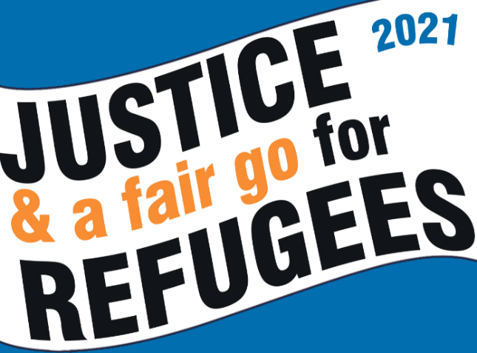
Be part of the national
PALM SUNDAY action calling for
Justice and a Fair Go for Refugees
#justice4refugees #GameOver

Palm Sunday (March 28) is an important opportunity to raise awareness of the continuing injustice and cruelty experienced by refugees and people who are seeking asylum. This year Palm Sunday actions are calling for:
- Permanent visas for all refugees
- Basic income support for people in the community while their refugee status is determined
- Release of ALL Refugees from detention #TimeForAHome
- An end to offshore processing #GameOver

There are lots of ways you can get involved!
- Attend the Justice and a Fair Go for Refugees Webinar on Tuesday 23 March, 7.30-8.30pm on zoom https://amnestyau.zoom.us/meeting/register/tJMod-CqqTwiHN2tsC7LzChFuMGOSLuzMyMj - to learn more about the issues and a discussion on what Justice and a Fair Go for refugees means. Hosted by the Australian Refugee Action Network and supported by Amnesty International. With Zaki Haidari, Farhad Bandesh, Atena Kashani, Sr Brigid Arthur, Prof John Minns and Dr Graham Thom (Amnesty International). Share the FB event to help us promote this important discussion https://fb.me/e/4Z07XHf6A
- Follow the Speaking Up for Refugees FB page and share posts on your own social media – use hashtags #justice4refugees #GameOver
- Post your own messages of support on your social media page. If you don’t use social media send a message of support for posting on the Speaking up for Refugees FB page to palmsundayrefugeemessages@gmail.com
- Lobby your local MP – see background information on the issues at ARAN Palm Sunday webpage
- Take the online actions suggested at ARAN Palm Sunday webpage
- Attend an action on Palm Sunday – these will be organized to be Covid-safe. See listing of actions on the ARAN Palm Sunday webpage .
- Organize your own event – let us know about your event by emailing palmsundayrefugeemessages@gmail.com. See resources to help publicize your event at ARAN Palm Sunday webpage
- Faith groups can remember refugees in services on (or around) Palm Sunday. Some churches are planning to ring their bells for refugees. Download a poster and signage about bell ringing at ARAN Palm Sunday webpage . Let us know if you will be ringing your bells by emailing palmsundayrefugeemessages@gmail.com
Resources and more info are available on the Palm Sunday page of the ARAN website https://aran.net.au/campaigns/palm-sunday-2021/:
- Graphics and Templates
- to promote your activities and social media posts
- Talking points
- to support your lobbying activities
- Background material
- for media articles, etc
- Social Media campaign information including tips for making a good quality video clip on your phone.

If you have queries email info@refugeeadvocacynetwork.org.au or call 0409 252 673.

