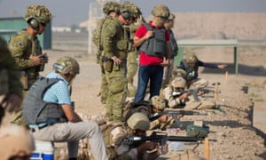

Interpreters who assisted Australian troops in Iraq are   
now in danger, and cannot apply for visas.

We must not abandon these people.

*Dear _____________________________*

A spokesman for the Australian defence department said [existing legislation allowed interpreters to apply for visas](https://www.legislation.gov.au/Details/F2012L02566/Explanatory%20Statement/Text)   
if a government minister certified they were at “at significant risk of harm as a result of their employment or support of Australia’s mission”.

Visa applications must be lodged at an Australian overseas mission, but [Australia’s embassy in Baghdad does not accept visa applications](https://iraq.embassy.gov.au/bdad/contact-us.html).

**I call on you to take this urgently to the Ministers for Defence and Immigration, and demand Australia protects those it has put in harm’s way.**

*Sincerely,*

*…………………………………………………………………...*

*Information provided by Guardian Australia*